**DAF Air Taxi Simulation: Brief Manual**

**Running the model**

In order to run the simulation, type in the following command in the main project folder:

airtaxi.models.example_model.runModel

**Setting up the simulation**

The main wrapper function for the simulation is the file runModel.m located at “+airtaxi/+models/example_model”. The simulation duration and user input files are specified in runModel.m as seen in Fig.1.

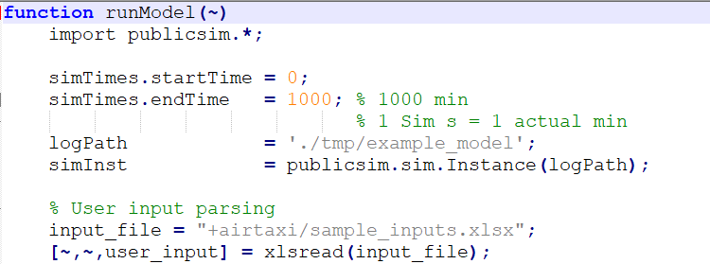

**Figure 1: Simulation Parameters**

**User input file**

An example input file is provided, which lets the user select the assets for deployment and assign agent parameters. Figure 2 below shows a snapshot for the excel input file. The input files are parsed within the file setupScenario.m. The parsing is setup for the “sample_inputs.xlsx” input file.

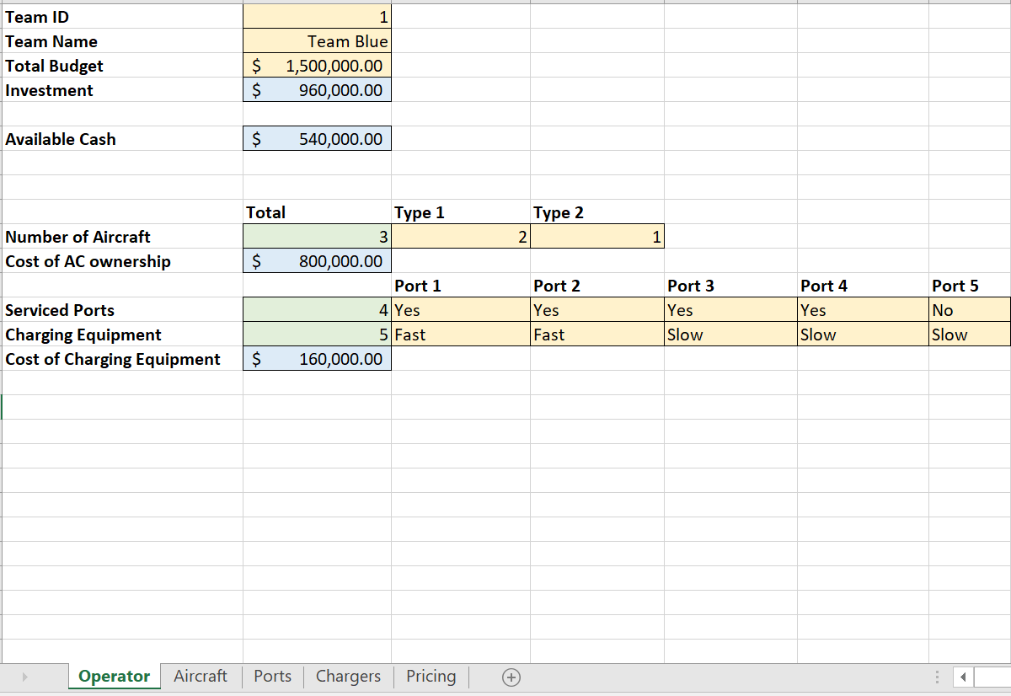

**Figure 2: Sample Excel Inputs File**

**Agents**

Currently, the DAF Air Taxi framework offers four agent templates, (i) Aircraft, (ii) Port, (iii) Operator and (iv) Customer. The aircraft and port are the key active agents in the simulation. Customers are defined as classes which can be instantiated at each port. Operator agent allows a centralized location for a team’s aircraft fleet and serviced ports to share relevant operational information required for simulation.

The real-time plots for the agents is controlled by the Plotter class located at “+airtaxi/+funcs/+plots”. Each agent has a plotter attribute which is an instance of the Plotter class. The plotting setup for real-time plots is defined within the setup() function within the class. The function is called at the setupScenario.m file before the simulation starts.

During the simulation, aircraft and port agents have a property logging function addPropertyLogs(). The property logging for the Aircraft agent is shown in Fig. 3.

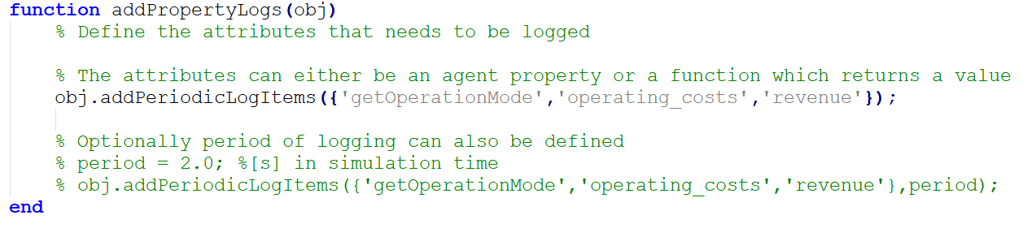

**Figure 3: Property logging function for Aircraft agent**

The properties logged during the simulation are stored at the logPath defined in the “runModel.m” file as shown in Fig. 1.

**Post processing Data**

The data logged during the simulation is parsed within the “parseLogs.m” file located at “+airtaxi/+funcs/”. The parsed data is fed into the “processData.m” file located at “+airtaxi/+models/+example_model” which plots the data for analysis.